Student ID: 2, 5, 9,
Group No: E
DATA SHEET:

Table 1: Measuring current through the Diode.
Serial no. | DC Supply  Voltage ($V_{DC}$)  (V) | Measured Voltage of Diode ($V_{D}$)  (V) | Measured Current of Diode ($I_{D}$)  (mA) | Calculated Current of Diode  I = $\frac{V_{dc}-V_{d}}{R}$  (mA)
 | 0 | 0 | 0 | 0
 | 0.3 | 0.226 | 0.00 | 0.074
 | 0.6 | 0.468 | 0.01 | 0.12
 | 0.9 | 0.553 | 0.25 | 0.347
 | 1.2 | 0.581 | 0.50 | 0.619
 | 1.5 | 0.602 | 0.82 | 0.898
 | 1.8 | 0.612 | 1.05 | 1.188
 | 2.1 | 0.625 | 1.39 | 1.475
 | 2.4 | 0.634 | 1.70 | 1.766
 | 2.7 | 0.638 | 1.93 | 2.062
 | 3 | 0.646 | 2.24 | 2.354
 | 3.3 | 0.651 | 2.47 | 2.649
 | 3.6 | 0.656 | 2.81 | 2.944
 | 3.9 | 0.659 | 3.09 | 3.424
 | 4.2 | 0.663 | 3.36 | 3.537
 | 4.5 | 0.668 | 3.68 | 3.832
 | 4.8 | 0.672 | 4.03 | 4.128
 | 5.1 | 0.674 | 4.27 | 4.426
 | 5.4 | 0.678 | 4.62 | 4.722
 | 5.7 | 0.679 | 4.78 | 5.021

Expected Waveforms:
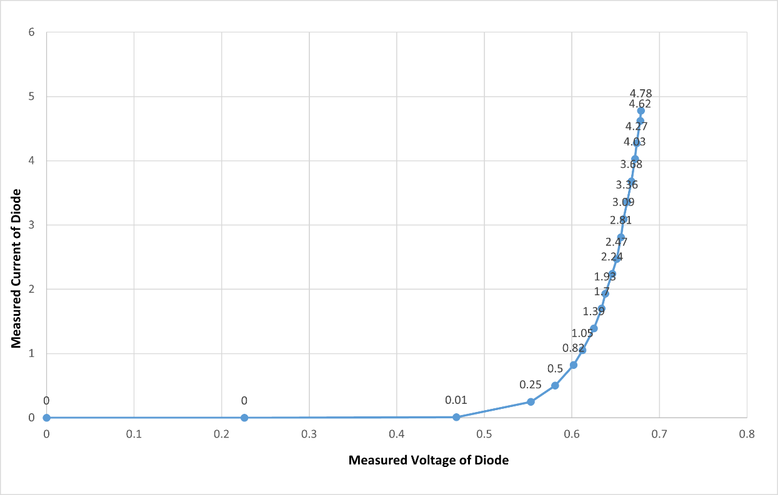
Graph 1.1: $I_{D}$ vs $V_{D}$

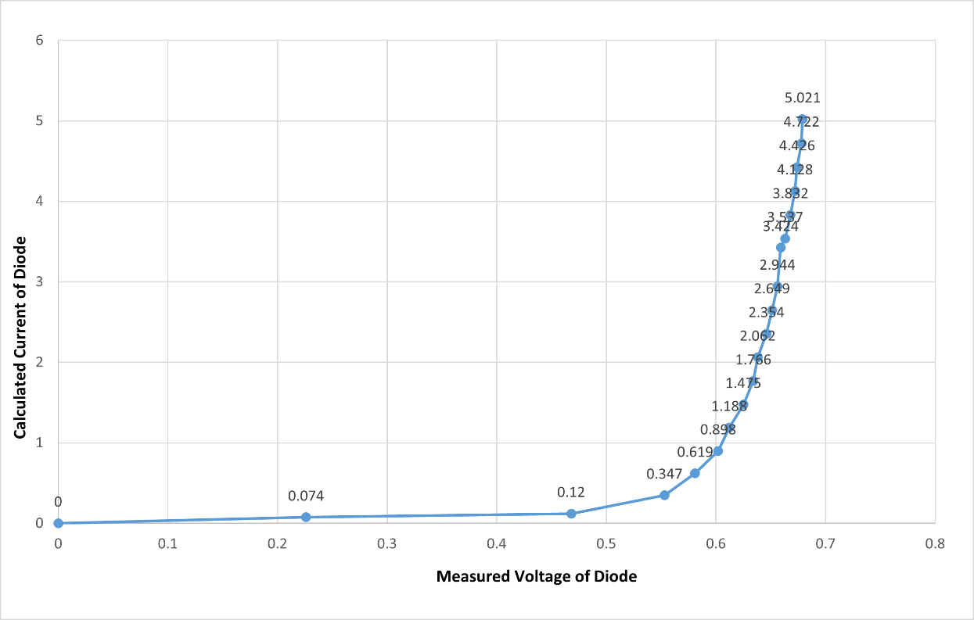
Graph 1.2: $\frac{V_{dc}-V_{d}}{R}$ vs $V_{D}$
I-V Characteristics Curve:
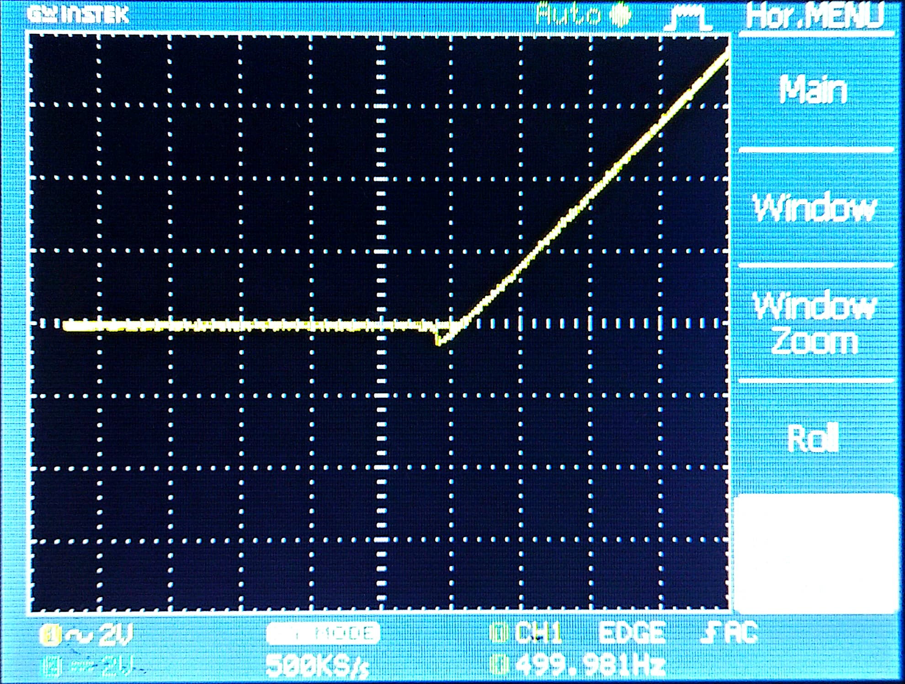
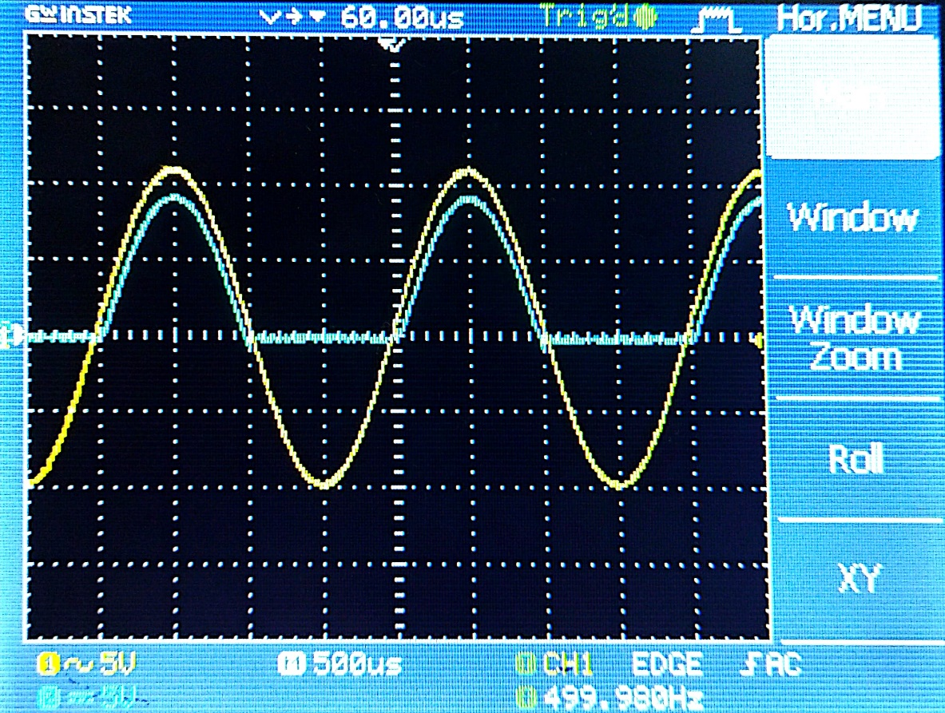
Figure 1.5: I-V Characteristic Curve in X-Y mode
Figure 1.4: Half wave Rectifier
Figure 2.2: I-V Characteristic Curve in X-Y mode

